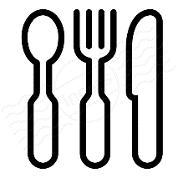
Breakfast Burritos – Filling Ingredients

Ingredients:
2 | Eggs | 2T. | Bacon
2T. | Milk | 1 | Soft Taco Tortilla
2T. | Shredded Cheese

Directions:
- In a small bowl, lightly beat eggs and milk. Cook in greased frying pan like making scrambled eggs.
- Heat prepared tortillas in microwave for 15 seconds each.
- Place tortillas on plates. Sprinkle with bacon pieces, top with scrambled eggs, sprinkle with cheese.
- Roll up “burrito” style.

May top burrito with salsa if desired.

